**Simple spark streaming example:**

Spark-shell

Word count for streaming data:

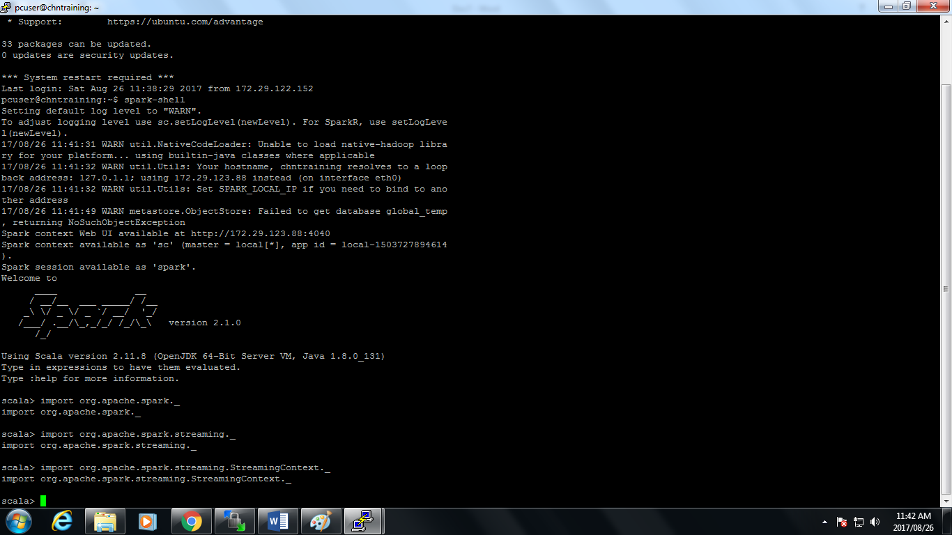import org.apache.spark.streaming._

import org.apache.spark.streaming.StreamingContext._

val conf = new SparkConf().setMaster("local[2]").setAppName("NetworkWordCount")

val ssc = new StreamingContext(conf, Seconds(10)) //streaming data duration(rdd distance).

val lines = ssc.socketTextStream("localhost", 9980) //my server

val words = lines.flatMap(_.split(" "))

val pairs = words.map(word => (word, 1))

val wordCounts = pairs.reduceByKey(_ + _)

wordCounts.print()

ssc.start()

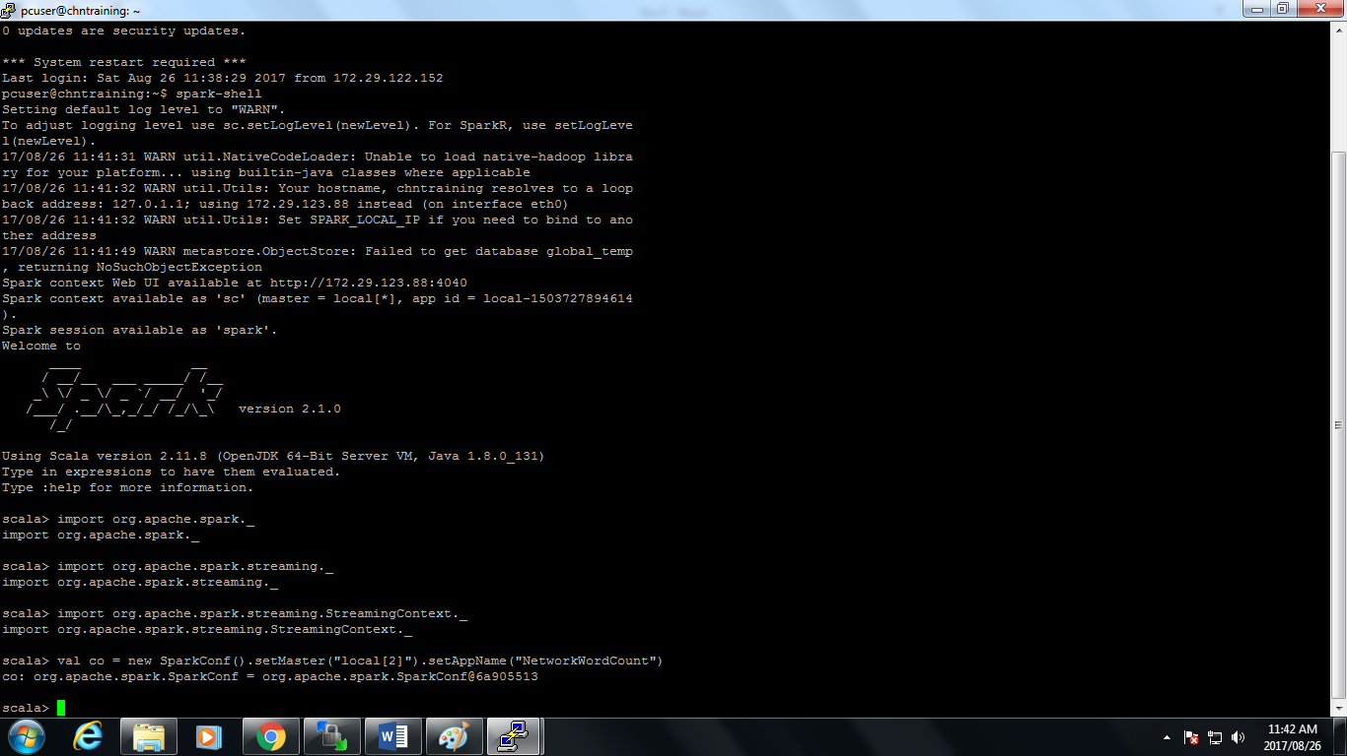

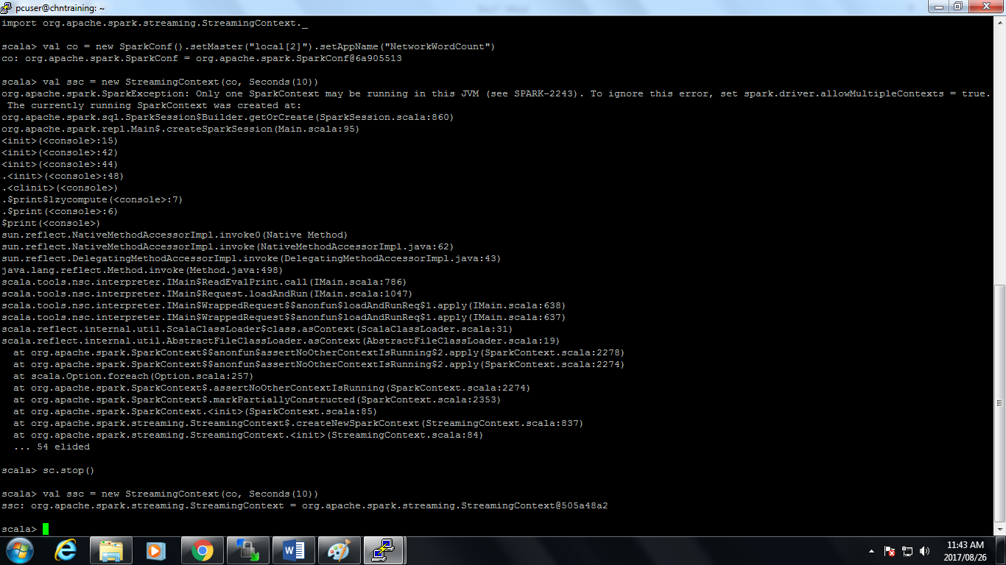

//error cause already running sparkcontext.

**Result1: port 9986**

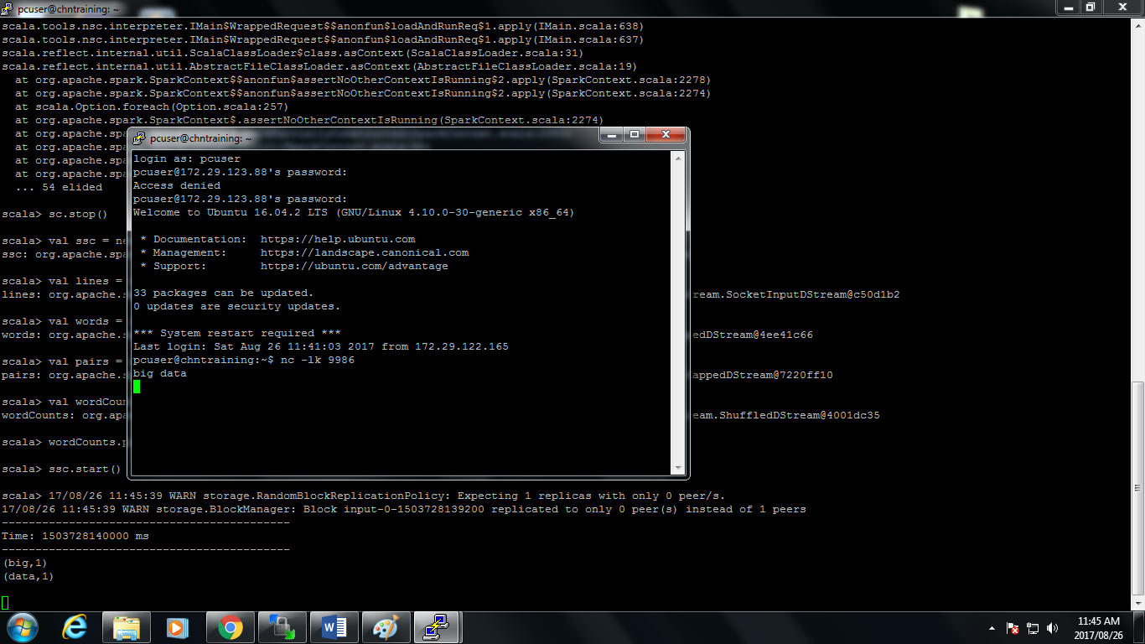

Result 2**: port 9980**

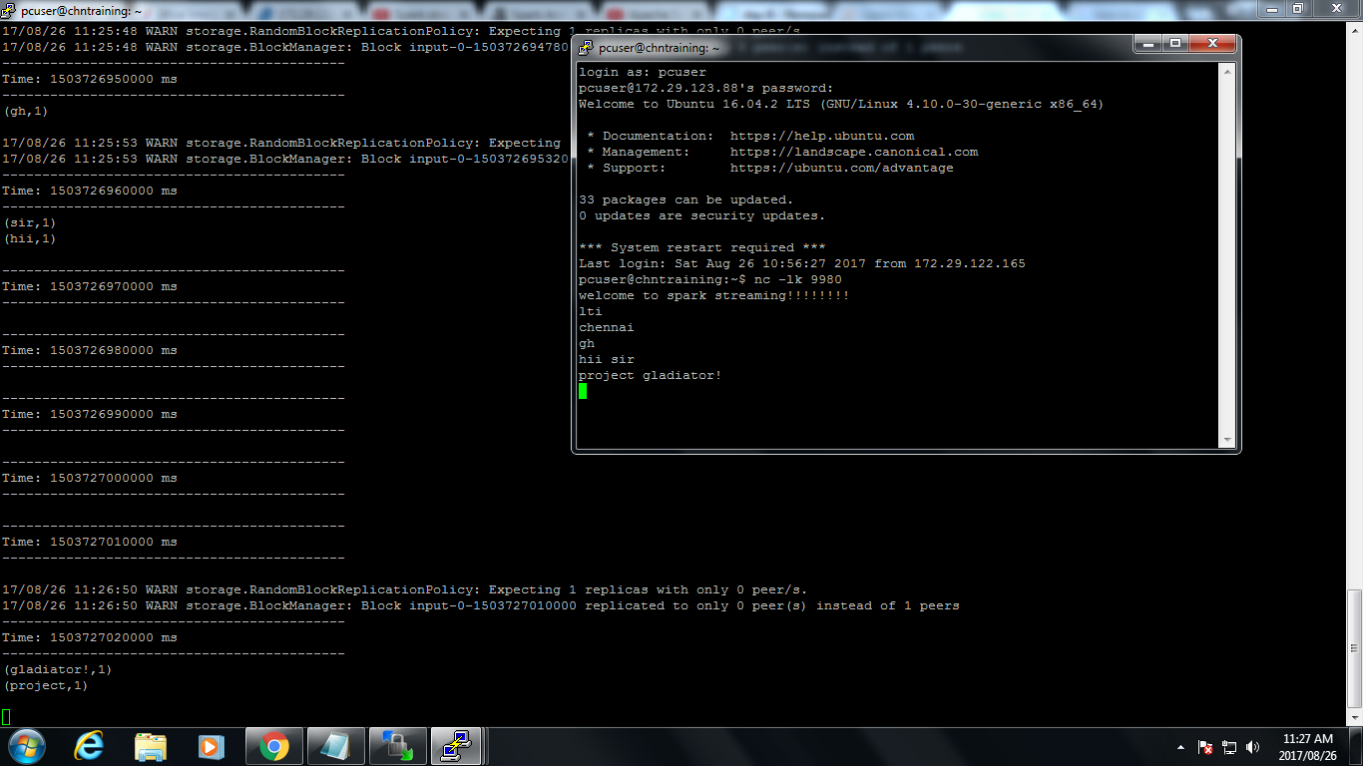

//starting the server

nc -lk 9980

//to stop the spark context

sc.stop()

//if this dosnt work then try to reuse existing context or create a new one you can use SparkContex.getOrCreate method.

val sc1 = SparkContext.getOrCreate(conf) //conf is the existing context

sc1.stop() //stopping the spark context

**Spark streaming twitter using java:**

Create a project in maven.

Change setting in pom.xml file

Create java program to receive Dstream

Generate maven :install maven

Run as java application,run this in jdk.

